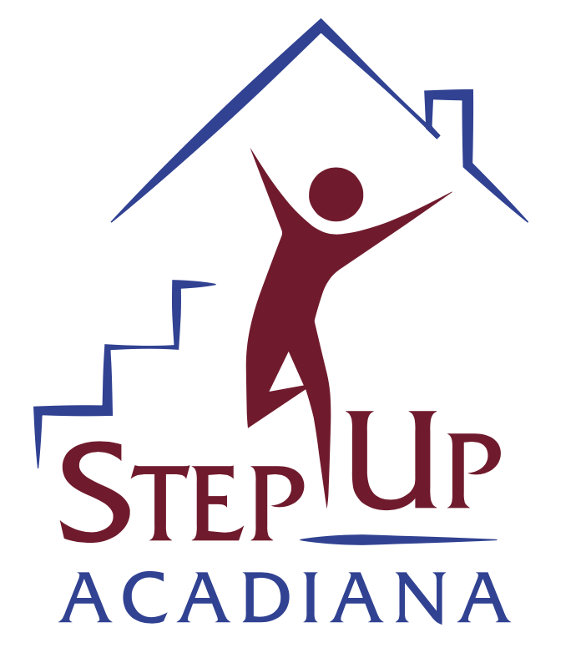
STEP UP ACADIANA Housing Counseling Intake

Name
First Middle Last

Mailing address
Street Address or PO Box #

City State ZIP Code

Email address

Date of Birth

Home # Cell #

Education level

Gender (circle one) Male Female Other__________________

Marital Status (circle one): Single Married Engaged Divorced Separated Widowed

Do you rent or own your current residence? (circle one) Rent Own Live with Family

How many people are in your household?

How did you hear about us?

Ethnicity (circle one) Hispanic or Latino Not Hispanic or Latino

Race (circle one or more)
American Indian or Alaska Native
Asian
Black or African American
Native Hawaiian or Other Pacific Islander
White

Did you serve in the US Military? YES or NO Are you disabled? YES or NO

Household Yearly Income _________________________________

Employer (or source of income)

How long have you been with your current employer?

Signature___________________________________ Date___________________

Client Counseling Authorization

- I understand that STEP UP ACADIANA provides foreclosure mitigation counseling and housing counseling; after which I will receive a written action plan consisting of recommendations for handling my finances, possibly including referrals to other housing agencies as appropriate.

- I maybe be referred to other housing services of the organization or another agency or agencies as appropriate that may be able to assist with particular concerns that have been identified. I understand that I am not obligated to use any of the services offered to me.

- A counselor may answer questions and provide information, but not give legal advice. If I/we want legal advice, I will be referred for appropriate assistance.

- I understand that STEP UP ACADIANA counselors may discuss information about my/our credit history, financial situation, employment, or other family problems. I authorize STEP UP ACADIANA to release credit, financial, employment and other information to other agencies or firms as may be essential to the solving of our housing problem.

- I understand that STEP UP ACADIANA may refer me to lenders so that I may submit an appropriate loan application, where applicable. I hereby explicitly give lenders or potential lenders permission to share my application with STEP UP ACADIANA for their reporting purposes and hereby waive any prohibitions of such disclosure under GLBA privacy provisions and Regulation P of the Code of Federal Regulations.

- I understand that if any information provided by me is found to be falsified, legal action can and will be taken against me.

- I understand by signing this document that I am not guaranteed assistance.

Client Signature: Date:

Privacy Policy

STEP UP ACADIANA is committed to assuring the privacy of individuals and/or families who have contacted us for assistance. We realize that the concerns you bring to us are highly personal in nature. We assure you that all information shared both orally and in writing will be managed within legal and ethical considerations. Your “nonpublic personal information,” such as your total debt information, income, living expenses and personal information concerning your financial circumstances, will be provided to creditors, program monitors, and others only with your authorization and signature on the Client Counseling Authorization Form. We may also use anonymous aggregated case file information for the purpose of evaluating our services, gathering valuable research information and designing future programs.

Types of information that we gather about you:
- Information we received from you orally, on applications or other forms, such as your name, address, social security number, assets and income;
- Information about your transactions with us, your creditors, or others, such as your account balance, payment history, parties to transaction and credit card usage; and
- Information we receive from a credit-reporting agency, such as your credit history.

You may opt-out of certain disclosures:
- You have the opportunity to opt-out of disclosures of your nonpublic personal information to third parties (such as your creditors), that is, direct us not to make those disclosures.
- If you choose to “opt-out,” we will not be able to answer questions from your creditors. If at any time, you wish to change your decision with regard to your “opt-out,” you may call or email us.

Release of your information to third parties:
- So long as you have not opted-out, we may disclose some or all of the information that we collect, as described above, to your creditors or third parties where we have determined that it would be helpful to you, would aid us in counseling you, or is a requirement of grant awards which make our services possible.
- We may also disclose any nonpublic personal information about you or former customers to anyone as permitted by law (for example, if we are compelled by legal process).
- Within the organization, we restrict access to nonpublic personal information about you to those employees who need to know that information to provide services to you. We maintain physical, electronic and procedural safeguards that comply with federal regulations to guard your nonpublic personal information.

Client Signature: Date:

Program Disclosure Form
NOTE: If you have an impairment, disability, language barrier, or otherwise require an alternative means of completing this form or accessing information about housing counseling, please talk to your housing counselor about arranging alternative accommodations.
About Us and Program Purpose: Step Up Acadiana is a nonprofit housing counseling agency.

Our agency provides the following one-on-one housing counseling services: pre-purchase/home buying; resolving delinquency and foreclosure prevention counseling.

Our agency also provides the following group education workshops: Financial literacy and pre-purchase/home buyer education.

We serve all clients regardless of income, race, color, religion/creed, sex, national origin, age, family status, disability, or sexual orientation/gender identity. We administer our programs in conformity with local, state, and federal anti-discrimination laws, including the federal Fair Housing Act (42 USC 3600, et seq.).

Termination of Services: Failure to work cooperatively with your housing counselor and/or Step Up Acadiana will result in the discontinuation of counseling services. This includes, but is not limited to, missing two consecutive appointments.
Agency Conduct: No Step Up Acadiana employee, officer, director, contractor, volunteer, or agent shall undertake any action that might result in, or create the appearance of, administering counseling operations for personal or private gain, provide preferential treatment for any person or organization, or engage in conduct that will compromise our agency’s compliance with federal regulations and our commitment to serving the best interests of our clients.
Agency Relationships: Step Up Acadiana has financial affiliation (if funded by HUD) or professional affiliations with HUD, USDA Rural Development, SMILE Community Acton Agency and Lafayette Habitat for Humanity; and banks including Home Bank, Bancorp South, MidSouth Bank and Iberia Bank. Step Up Acadiana was founded by Kevin Davis, a licensed real estate broker and owner of Sky Universal Realty.
As a housing counseling program participant, you are not obligated to use the products and services of Step Up Acadiana or our industry partners.
Alternative Services, Programs, and Products & Client Freedom of Choice: Step Up Acadiana has a first-time homebuyer program. However, you are not obligated to participate in this or other Step Up Acadiana programs and services while you are receiving housing counseling from our agency. You may consider seeking alternative products and services from entities including the Federal Housing Administration (FHA) for first-time homebuyer loan programs, and Lafayette Consolidated Government for other first-time homebuyer programs. You are entitled to choose whatever real estate professionals, lenders, and lending products that best meet your needs.
Referrals and Community Resources: If necessary, you will be provided a community resource list which outlines the parish and regional services available to meet a variety of needs, including utilities assistance, emergency shelter, transitional housing, food banks, and legal aid assistance.
Errors and Omissions and Disclaimer of Liability: I agree Step Up Acadiana, its employees, agents, and directors are not liable for any claims and causes of action arising from errors or omissions by such parties, or related to my participation in Step Up Acadiana counseling; and I hereby release and waive all claims of action against Step Up Acadiana and its affiliates. I have read this document and have signed it freely and without any inducement or assurance of any nature and intend it to be a complete and unconditional release of all liability to the greatest extent allowed by law. If any provision of this document is unenforceable, it shall be modified to the extent necessary to make the provision valid and binding, and the remainder of this document shall remain enforceable to the full extent allowed by law.
Quality Assurance: In order to assess client satisfaction and in compliance with grant funding requirements, Step Up Acadiana may contact you during or after the completion of your housing counseling service. You may be requested to complete a survey asking you to evaluate your client experience. Your survey data may be confidentially shared with Step Up Acadiana grantors such as HUD or NeighborWorks America.
I acknowledge that I have reviewed and agree to Step Up Acadiana’s Program Disclosures.

Signature Date

